♀31. Judgment. (Spaceship Earth, URI-IRU)--Track 35
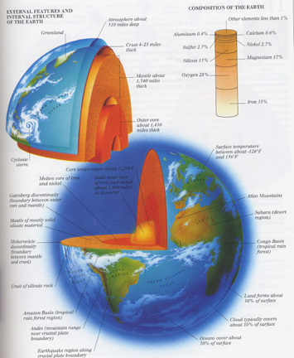
When you see the earth from the moon, you don’t see any divisions there of nations or states. This might be the symbol, really, for the new mythology to come. That is the country that we are going to be celebrating. And those are the people that we are one with.

There is an oddness about the memory which is somehow annoying. It gives a feeling of shame and guiltiness. There is a tendency to blush. One feels like a schoolboy caught red-handed in the act of writing poetry. There is the same sort of feeling as one has when one finds a faded photograph or a lock of hair twenty years old among the rubbish in some forgotten cabinet. This feeling is independent of the question whether the thing remembered was in itself a source of pleasure or of pain. Can it be that we resent the idea of our “previous condition of servitude”? We want to forget the past, however good reason we may have to be proud of it. It is well known that many men are embarrassed in the presence of a monkey.

